**LAB#03 – TASK#01**

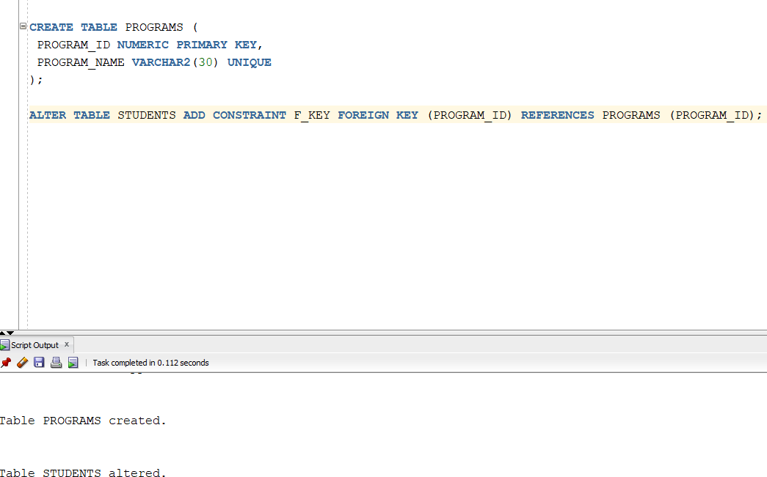

**LAB#03 – TASK#02**

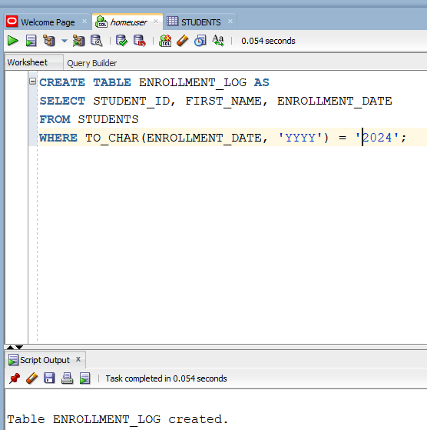

**LAB#03 – TASK#03**

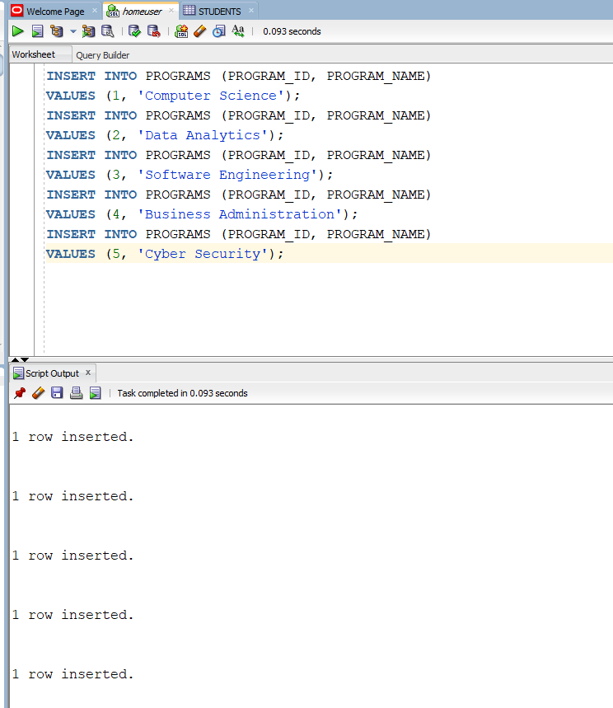

**LAB#03 – TASK#04**

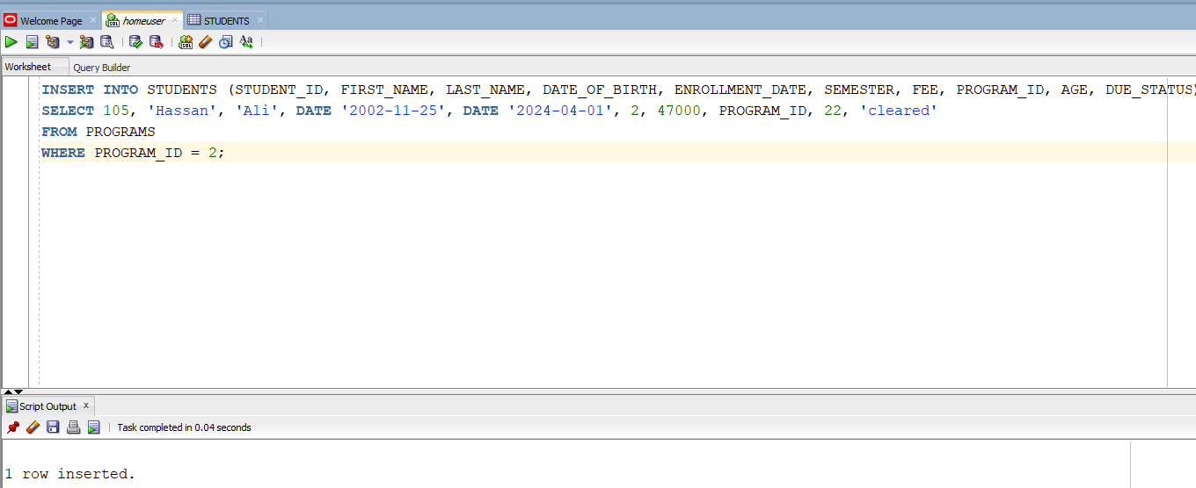

**NOW TRYING INVALID PROGRAM ID**

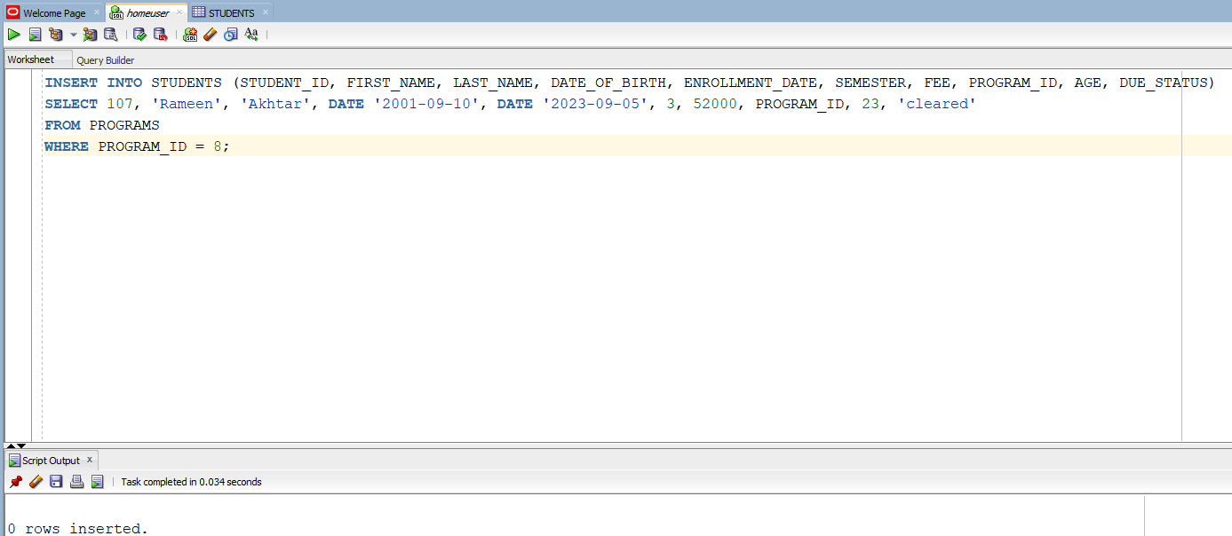

**LAB#03 – TASK#05**

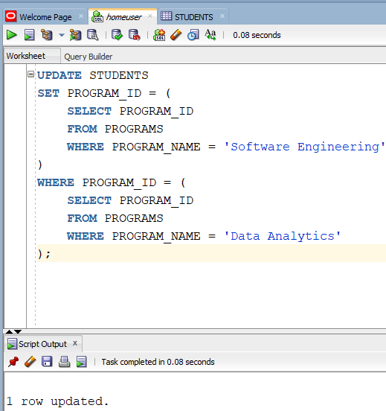

**LAB#03 – TASK#06**

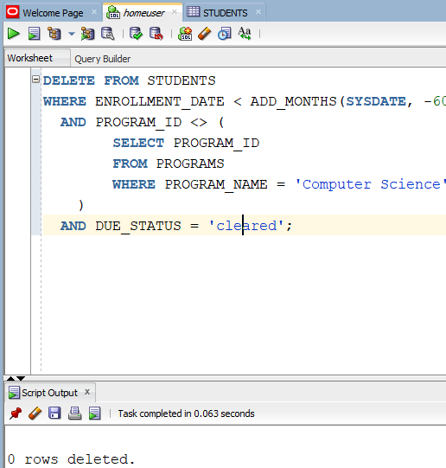

**LAB#03 – TASK#07**

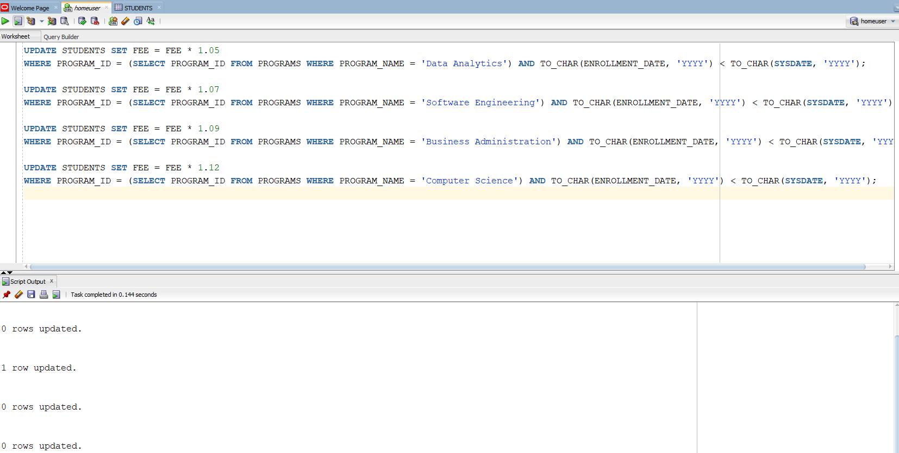

**LAB#03 – TASK#08**

